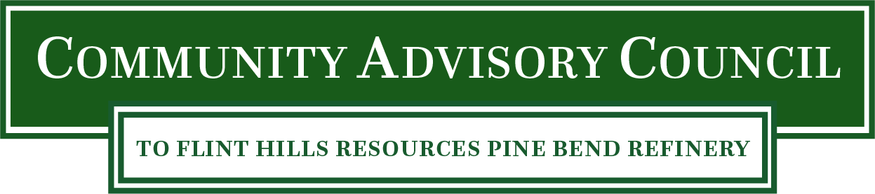

Council Meeting
Monday, March 13, 2023
6:00 PM – 8:30 PM
Location: Flint Hills Resources North Administration Building

Meeting Agenda

Public Comment

CAC Business

Flint Hills Resources Updates
- environmental, safety and community updates

Featured Presentation / Topic: Buffer Zones – Strategy / Vision, Maintenance

Meeting Wrap Up / Discuss Next Meeting’s Topics

